
KHULNA UNIVERSITY
190205 || 200240

Hotel Room Review Search Engine Report

Submitted to:
Dr.Amit Kumar Mondal
Associate Professor
Computer Science And Engineering Discipline, Khulna University

Submitted By:
Sumaiah Binta Musa, istyaque Ahammed
Student ID:190205.200240
Computer Science And Engineering Discipline,Khulna University

1. Task 1:
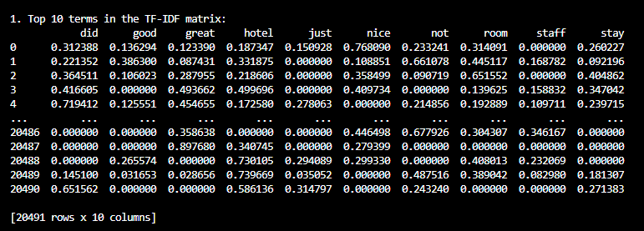
Top 10 terms in the TF-IDF matrix:

2. Task 2:
Top 10 terms term-term correlation matrix:
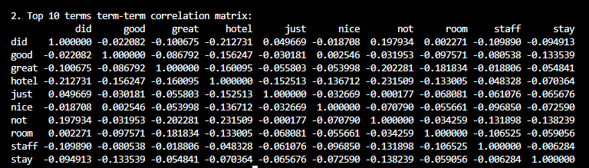

Words like “nice,” “good,” and “great” are often used together, indicating positive experiences with hotels. “Room” and “staff” have a mild correlation, suggesting that comments on the room often include feedback on staff, showing both are key factors in guest satisfaction. Terms like “not” and “did” are slightly correlated, often appearing together in critical statements, such as unmet expectations with room or hotel amenities.The link between “room” and “stay” suggests that room quality significantly impacts the overall stay experience.

3. Task 3
Top 5 search results for query: 'excellent service and clean rooms :

Result 1 (TF-IDF Sum: 1.54)
excellent, stayed hotel 13 19 april 2006.location excellent.rooms clean.prestige rooms big couple.separate shower bath.breakfast good clean selection better.general service attitude hotel employers excellent.this important attitude customer service france 0 1 10 range biggest issue france . . .

Result 2 (TF-IDF Sum: 1.45)
supereior amenities excellent service smiles difficult disappointed beautifully appointed rooms bath facilities, hotel newly refurbished feel look plus star hotel. . . .

Result 3 (TF-IDF Sum: 1.33)
great location service nice hostal just 50 meters plaza major close puerta del sol, rooms small bathroom clean, excellent price, enjoyed stayed, frontdesk service excellent. . . .

Result 4 (TF-IDF Sum: 1.26)
good-sized clean rooms service improved booked standard room villa mazarin, centrally located walked major tourist sites rooms decent sized comfortable, let somewhat service desk no means rude feel. . . .

Result 5 (TF-IDF Sum: 1.26)
excellent affordable accommodations stay oakwood apartments shinjuku terrific, room bit small modern clean, service excellent amneties fabulous, located near shinjuku train station makes bonus traveller. . . .

4. Task 4
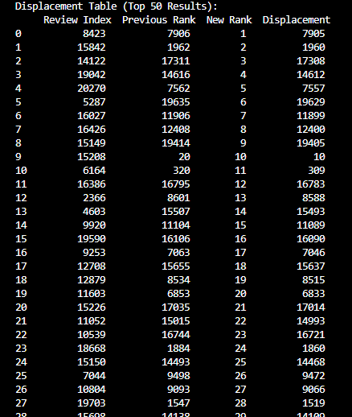

5. Task 5:
